Huawei in Europe: Chinese National Indigenous Innovation to Global Giant
Wiranya Sutthikulª
Waranthiya Sutthikul^{b}
Sujittra Hongyon^{c}
Kongkiat Sahayrak^{d}

Abstract
Huawei is currently the largest telecommunication company in China. However, the significance of the company is not only felt in China but also in the global market. The unremitting influence of Huawei in the global market is attributed to its pledge to technology innovation as well as R&D investment. In this paper aims to identify Huawei’s Europe expansion of telecommunication equipment, brand strategy, operation in R&D expenditure and the challenges as it makes the transition from Chinese business brand to a potentially competitive global stupendous.

KEYS: Huawei, R&D, innovation, brand strategy

Introduction
Huawei, a telecommunication corporation headquartered in Shenzhen, Guangdong, China, is the biggest telecommunication device producer across the globe. The company had an initial mission of providing consulting and operation services to businesses in China and the entire global at large. Huawei employs 140,000 people, among which 46% work in research and development (Hyman et al., 2018). Huawei products and services are in over one hundred and forty countries. It was first established as a sales agent where it used to manufacture private branch exchange switches. The brand has appeared in various international media group companies (Xia and Gan, 2017). Forbes is one of the major media group companies that have ranked Huawei among the best brands in the world. In 2018, Huawei was ranked 79th by Forbes (Herciu, 2018). According to the statistics in the rankings, the firm was valued at 8.4 billion US dollars. Its entrance into the list of Forbes most valuable brands for the first time in 2017 was associated with its rapid global development by manufacturing a range of products which did well in the worldwide market (Herciu, 2018). Some of the products which helped Huawei increase its value include the Mate, P, and Nova series (Herciu, 2018). Launching the products helped the company raise its premium credentials an aspect which raised the firm’s influence in the global telecommunication market.
Huawei also performed well in other brand rankings, conducted by other international audit companies. Herciu (2018) underlines that Brand Finance, one of the most influential brand ranking companies, numbered Huawei 25th in the list of the most valuable companies, with a brand value of 38 billion US dollars.
Huawei’s EU Expansion: Telecommunication Equipment
The European market is well known for high technology and service standards. Huawei is considered to be the largest telecommunications equipment supplier worldwide with the

Faculty of Business Administration and Management, Ubon Ratchathaini Rajabhat University, E-mail: wiranya.s@ubru.ac.th^{a,c,d}
College of Business, Columbia Southern University, E-mail: swaranthiya@yahoo.com^{b}

revenue of 712.2 billion yuan or $107.13 billion in 2018 (CNBC, 2019). In 2004 Huawei able to win its first major contract in Europe with the Dutch mobile operator Telfort later on 2007 Huawei was qualified to secure contracts with all first-tier network operators in Europe. In 2009 Telenor choosing Huawei offer over Ericsson’ and Nokia Siemens Network’s. In 2014 Vodafone awarded Huawei the contract to upgrade its networks in 15 countries in Europe and Africa (Jan Drahokoupil, 2017).
Huawei’s new product development is customer driven. The company is employee-owned with approximately half of the total employees working in research and development (Zidane et al., 2013). The organization considers its workforce as the most significant asset possessed by the company. Ren Zhengfei, the owner of the company, maintains that Huawei exists to satisfy its customers.

Figure 1 European smartphone shipments and annual growth
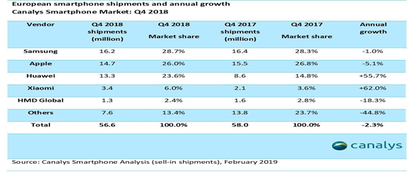
Source: Canalys smartphone analysis (sell-in shipments), February 2019

The latest figures from Canalys the market analyze have certified a trend of the rise of the Chinese phone in Europe. Canalys states that 32 percent, or one-third of smartphone shipments in Europe in 2018 were from Chinese manufacturers. On the other hand, Huawei uses design to value strategy. The company uses its resources and assets to better its services and products each day. Before its product penetrated Western countries, the brand engaged in processes which would help it design products suitable for the taste of European countries (Balmer and Chen, 2017). At one particular time, the company offered its designers a few weeks to develop cell-phones which would meet the market expectation of different markets in the world.

Brand Strategy
To remain the most successful telecommunication choice in the world, Huawei has mastered the current technological advancements in the field of communication. Moreover, the firm has invested a lot in research and development with a view of anticipating future customer needs. Establishing a competitive advantage by outsmarting current technology is an essential strategy for Huawei. There are approximately two hundred 4th generation (4G) networks operating in over seventy countries in the world. However, Huawei has been planning to develop a 5G network for several years. Their projection is to establish the 5G network by 2020. The company’s foresight will place it as one of the first movers in the fifth-generation network. According to the projection of the company, the fifth-generation network will be up to 100 times faster compared to the fourth-generation network. Huawei is taking advantage of its significant increase in economies of scale by leading the way in various industrial standards. As a result of its place in the global market, Huawei can establish technology policies which will facilitate its stay ahead of its immediate competitors.
On the other hand, the organization has been taking great strides in aligning its leadership management to stay responsive in the dynamic technological environment (Alvim, 2017). The company is operating under a string of leadership that promotes uniformity and control excellence. Despite the negative impact that the strategy may have on the firm, Huawei has managed to implement it successfully since it is usually crucial for branding as well as the development of innovations (Demestichas et al., 2013). Decentralized decisions are generally vital in improving and facilitating the growth of organizations. It utilizes decentralization of decision-making by delegating decision-making processes to customer-facing roles, an aspect which enhances the flow of ideas.Huawei also has one of the riskiest but brilliant jobs posting, which is based on rotating CEOs. The company has a docket of executives who rotates their duties in the organization (Chakravarthy and Yau, 2017). According to studies, CEO rotation is effective in improving the productivity of a company since executive members have time to prepare for their duties prior before reaching their term as acting CEOs. The organization can benefit from a broad breadth of expertise. The unique senior management strategy in Huawei enables it to possess fresh thinking regarding its brand strategy. Building a better-connected world is a major corporate brand theme that Huawei established in 2014 (Chakravarthy and Yau, 2017). Huawei has out-competed many telecommunication firms because of its sensitivity to customers’ need. The company builds awareness as well as invests in public relations, an aspect which accompanies it with significant growth in the global market.
The marketing strategy of Huawei is attributed to its product positioning, which epitomizes excellence. The launching of P7 Smartphone in 2014 justifies Huawei’s unique product positioning portraying a trendsetting company in the telecommunication sector (Chakravarthy and Yau, 2017). To express their leadership position in the global market, Huawei used a picture of light beam piercing the darkness to symbolize its authority in the global market. In 2012, other telecom providers exhibited their concern to Huawei’s decision to distribute its products under its brand name, rather than the Telecom Umbrella (Chakravarthy and Yau, 2017). However, the company never relented about its actions as it was committed to building its brand visibility.

Huawei’s Operation in EU: R&D Expenditure
Huawei has invested in R&D in various European countries including the UK, Finland, France, Belgium, and Germany, among many others (Schaefer and Liefner, 2017). According to reports, the company planned to increase its R&D expenditure to approximately 20 billion dollars (Schaefer and Liefner, 2017). The increase in spending came at a time when the company wanted to become a global leader in 5G technology. In 2017, Huawei spent over 13 billion dollars on R&D. The amount consumed approximately 15% of the company’s total revenue that year (Schaefer and Liefner, 2017). Also, the company pledged to dedicate about 30% of the total R&D expenditure on basic science research (Schaefer and Liefner, 2017). The telecommunication firm provided the statistics in a statement in 2017.

Figure 2 R&D investment by main world region in 2015-2016
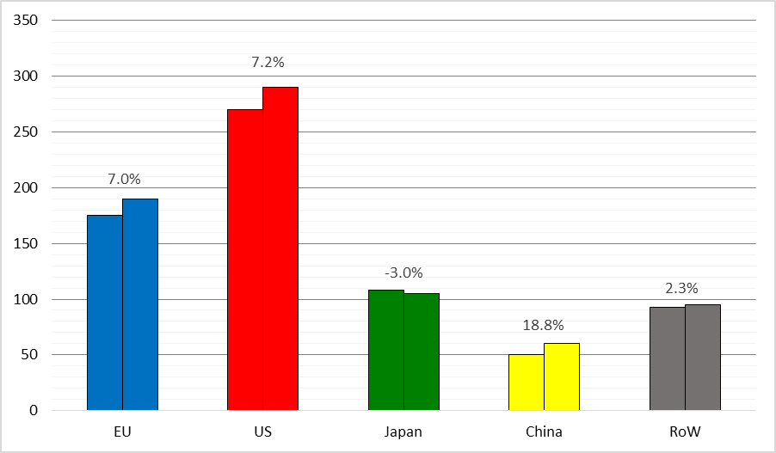
Note : growth rates have been computed for 566 EU, 818 US, 364 Japanese, 375 Chinese and 370 RoW companies for which data are available for both years 2015 and 2016.
Source: The 2017 EU Industrial R&D Investment Scoreboard, European Commission, JRC/DG RTD.

Based on the figures, Huawei forms one of the world’s top R&D spenders. According to financial data company fact set, Amazon and Alphabet are a few companies which spent more in R&D compared to Huawei. However, based on the history of the brand as well as its magnitude, its expenditure had a considerable significance in the future dynamics of global business. The largest contribution to the R&D growth of non-EU companies was made by ICT services showing high R&D growth were HUAWEI 29%. The 376 Chinese firms showed a strong growth in net sales +7.4% and net profits +13.4% reaching a profitability level of 6.9%. Chinese companies escalate employees' 4.4%. On the other hand, Huawei’s R&D expenditure is exhibited in its workforce orientation, where over 46% of employees are engaged in research and development (Deng and Mao, 2018). Huawei’s increased cost comes at a time when the US, Australia, and other nations have subjected the company to bans, which target its products (Deng and Mao, 2018). The decisions to ban Huawei products are based on the allegiance that the company subjects other countries to security issues amid international political tensions. For instance, in 2018, the UK reported the presence of technical and supply-chain issues with Huawei (Deng and Mao, 2018). According to the report, Huawei exposed telecom networks based in the UK to security risks.
Also, the business committed to open R&D centers in France in 2018. The centers were projected to focus on Smartphone sensors and the invention and innovation of parallel computing software. Huawei also projected the number of workers in the expected R&D center to grow to 30 at the turn of 2020 (Lin et al., 2018). At the time of its plan to open a research and development center in France, Huawei had around 350 employees working in different R&D stations in Switzerland. By 2021, Huawei will invest another US$ 50 million to construct more of the OpenLabs to assist more European companies go digital and enlarge their influence in the global (Abraham Liu, 2019).

Management Method and Employee Relation
Huawei has one of the most successful management strategy and employee relations in the business sector. As a global organization, the company promotes synchronized social development besides focusing on the development of the firm (Huang and Huawei, 2010). Also, the organization incorporates sustainable requirements in its business undertakings and establishes management systems which help in achieving desired sustainable initiatives. Huawei looks into the future with the successful projection of its performance in the telecommunication industry. However, the firm makes it open for the public to understand that its purpose revolves around empowerment of society. To achieve all its desires, Huawei works harmoniously with other stakeholders in the business ecosystem.
One of the most standing out management method that Huawei has used over time is concentrating on cost leadership. Huawei was able to build its brand name from the production of affordable products. The corporation was able to strategize on low-cost product manufacturing since labor cost in China was economical as well as readily available (Yusheng, 2013). Over the years, the company was able to produce cheap products successfully while building its brand name (Chakravarthy and Yau, 2017). However, to export its presence in the global market, Huawei got the cutting edge from other foreign companies such as Intel. The company’s product differentiation was able to be recognized in most parts of the world because of its decision to increase R&D centers’ expenditure.
On the other hand, Huawei has a management system which is grounded on empowering people through communication. The concept is derived from the firm’s vision and mission statements which translate to a common goal of focusing on customers’ requirements and providing them with necessary ICT solutions and services needed to improve their communication experience.

Future Challenges for Huawei
Although Huawei has experienced unprecedented success in the field of telecommunication, it has also its set of business challenges which have affected its operation for the past three decades. However, the company is more concerned with its future problems, which are projected to be more based on the changing dynamics of technology in the current world (Nakai and Tanaka, 2010). Among the primary future problem of Huawei is continuing the pace of innovation. Past experiences have shown that monopolistic powers are temporary (Fan and Bifet, 2013). Therefore, the organization has to avoid complacency since many big companies fell as a result of ignorance. Brand image in the US is another future challenge which has already started manifesting itself. The US government has recently expressed its dissatisfaction with Huawei because of potential Chinese state security concerns. For the past decade, Huawei has been a subject of political scrutiny (Wu, Hoon and Yuzhu, 2013). US government officials have occasionally been seen warning on doing business with Huawei. Therefore, the company’s greatest future challenge is how the US’s government perceives the brand and its honesty.

Conclusion
In conclusion, Huawei needs to review its global business strategy and establish another crucial step which will help move it further in the global market position. Moreover, the company should focus on the possible future challenges to ensure its leadership position is not ruined because of complacency. Even though investing in R&D is vital in building its brand, Huawei needs to focus more on the customers’ needs. However, small the number of people who would want certain features installed in their products. Nokia should serve as an example of a company which saw her brand value fall because of complacency. While Nokia invested more in R&D compared to Apple, it lost its position since it failed to deliver customers’ interest concerning touch-screen between 2004 and 2007. Therefore, Huawei should learn from other great corporations which saw their brand name fall as a result of complacency.

References
Abraham Liu, (2019). Retrieved from https://www.huawei.eu/story/why-europe-and-huawei-
need-stick-together
Alvim, M.M.M.V.C., (2017). Huawei case study: A reposition challenge to achieve
leadership. Doctoral dissertation.
Balmer, J.M. and Chen, W., (2017). China’s brands, China’s brand development strategies
and corporate brand communications in China. In Advances in Chinese brand management (pp. 19-47). Palgrave Macmillan, London.
CNBC, (2019). Retrieved from https://www.cnbc.com/2019/03/29/huawei-earnings-full-year-
2018.html
Chakravarthy, B. and Yau, D., (2017). Becoming global leaders: Innovation challenges for
five large Chinese firms. Strategy & Leadership, 45(2), pp.19-24.
Demestichas, P., Georgakopoulos, A., Karvounas, D., Tsagkaris, K., Stavroulaki, V., Lu, J.,
Xiong, C. and Yao, J., (2013). 5G on the horizon: Key challenges for the radio-access network. IEEE Vehicular Technology Magazine, 8(3), pp.47-53.
Deng, Z., Zou, Y. and Mao, J.Y., (2018). Unconventional internationalization of Huawei: The
role of core values. In Business despite borders (pp. 179-191). Palgrave Macmillan, Cham.
Fan, W. and Bifet, A., (2013). Mining big data: Current status, and forecast to the future.
ACM sIGKDD Explorations Newsletter, 14(2), pp.1-5.
Herciu, M., (2018). Market capitalization, enterprise value and brand value of the worlds
most reputable companies. Economic and Social Development: Book of Proceedings, pp.420-428.
Huang, S., Huawei Technologies Co Ltd, (2010). Method and system for a traditional
terminal user to access an IMS domain. U.S. Patent 7,643,474.
Hyman, J., Acker, J., Ackers, P., Marchington, M., Wilkinson, A., Goodman, J., Ackroyd, S.,
Thompson, P., Adams, S., Addison, J. and Schnabel, (2018). Employee stock ownership plans and their effect on productivity: the case of Huawei. In Employee voiceand participation: Contested past, troubled present, uncertain future (Vol. 20, No. 4, pp. 1-13). London: Sage.
Jan Drahokoupil, (2017) . Chinese investment in Europe:corporate strategiesand labour
relations pp 26-277
Lin, X., Liu, B., Han, J. and Chen, X., (2018). Industrial upgrading based on global
Innovation chains: A case study of Huawei technologies Co., Ltd. Shenzhen. International Journal of Innovation Studies, 2(3), pp.81-90.
Nakai, Y. and Tanaka, Y., (2010). Chinese company's IPR strategy: How Huawei
echnologies succeeded in dominating overseas market by Sideward-Crawl Crab Strategy. In Picmet 2010 Technology Management for Global Economic Growth (pp. 1-5). IEEE.
Schaefer, K.J. and Liefner, I., (2017). Offshore versus domestic: Can EM MNCs reach higher
R&D quality abroad? Scientometrics, 113(3), pp.1349-1370.
Wu, F., Hoon, L.S. and Yuzhu, Z., (2011). Dos and don'ts for Chinese companies investing in
the United States: Lessons from Huawei and Haier. Thunderbird International Business Review, 53(4), pp.501-515.
Xia, W. and Gan, D.Z., (2017). The marketing strategy of HUAWEI Smartphone in China.
ICMSIT 2017: 4 th International Conference on Management Science, Innovation, and Technology 2017, pp. 144-155.
Yusheng, W.J.B., (2013). TMT attention distribution and international expansion strategy
choice: A case study on Huawei Technologies Ltd.[J]. Chinese Journal of Management, 9.
Zidane, R., Huberman, S., Leung, C. and Le-Ngoc, T., 2013. Vectored DSL: benefits and
challenges for service providers. IEEE Communications Magazine, 51(2), pp.152-157.

